Leandro Clavijo

Practica de ARRAY

Programación

* **Array 1**

package array1;

import java.util.Scanner;

public class Array1 {

public static void main(String[] args) {

Scanner leer = new Scanner(System.in);

int [] vector;

vector = new int [10];

for (int i = 0; i<vector.length;i++)

{

System.out.print(vector[i]+" ");

}

}

}

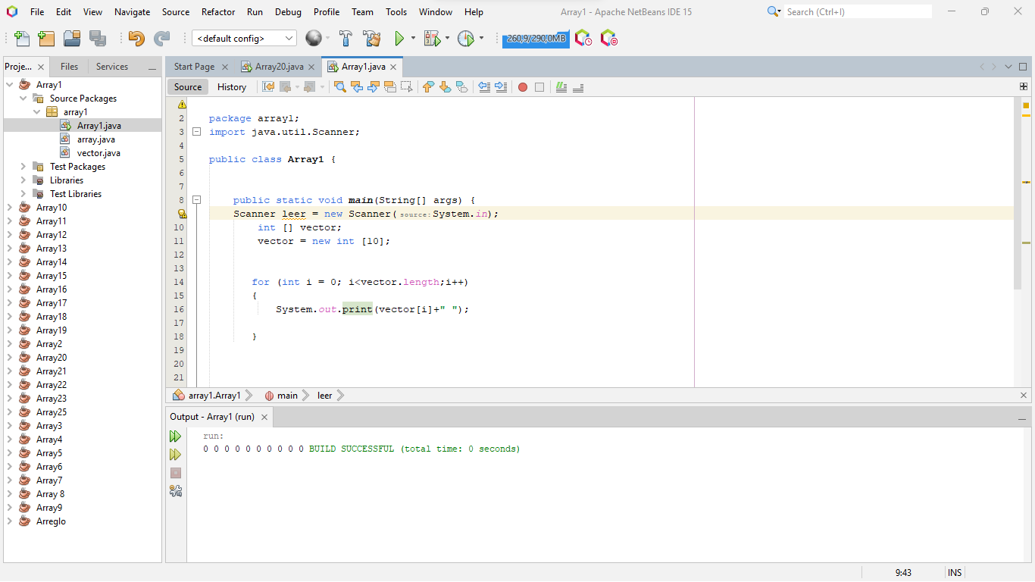

* **Array 2**

package array2;

import java.util.Scanner;

public class Array2 {

public static void main(String[] args) {

int [] numero;

numero = new int [20];

int n1=0;

for (int i = 0 ;i < numero.length; i++)

{

numero [i] = n1;

n1 = n1+1;

System.out.println(numero[i]);

}

}

}

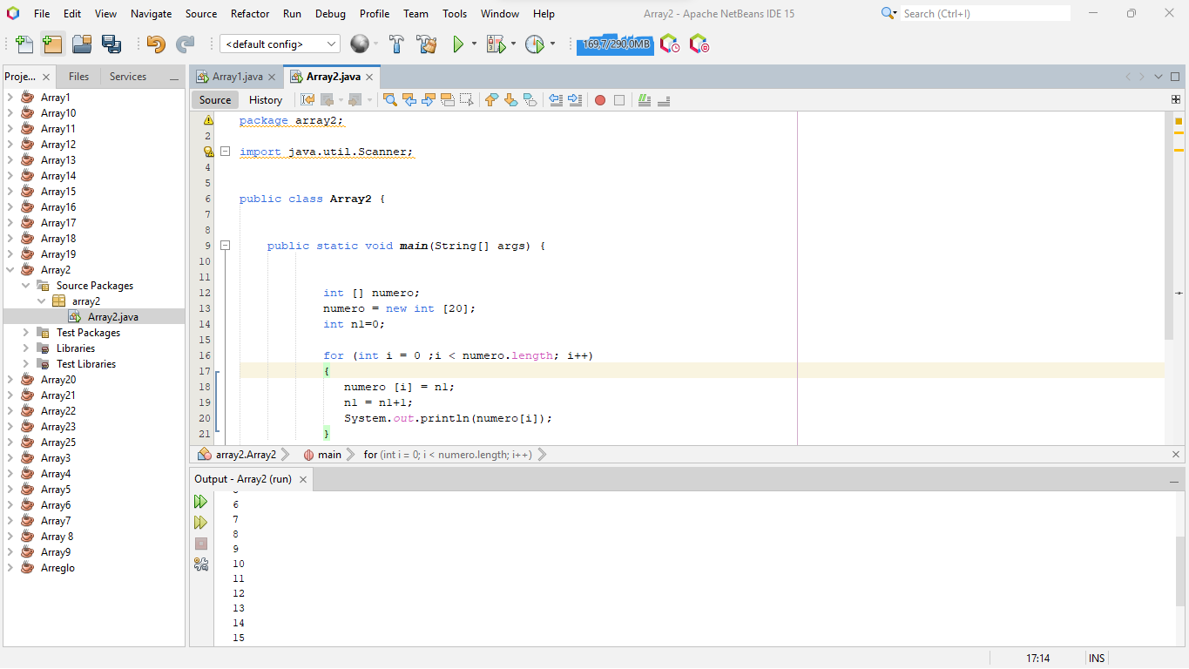

* **Array 3**

package array3;

import java.util.Scanner;

public class Array3 {

public static void main(String[] args) {

int numero [] = new int[5];

Scanner reader = new Scanner(System.in);

int conp = 0;

int conn = 0;

int conc = 0;

for (int i=0;i<numero.length;i++)

{

System.out.println("Ingrese un numero: ");

numero[i] = reader.nextInt();

}

for(int i = 0; i<numero.length;i++)

{

if (numero[i] > 0)

{

conp++;

}

else if (numero[i] < 0)

{

conn++;

}

else

{

conc++;

}

}

System.out.println("Ingreso "+conp+" positivos");

System.out.println("Ingreso "+conn+ " negativos");

System.out.println("Ingreso "+conc+ " numero 0");

}

}

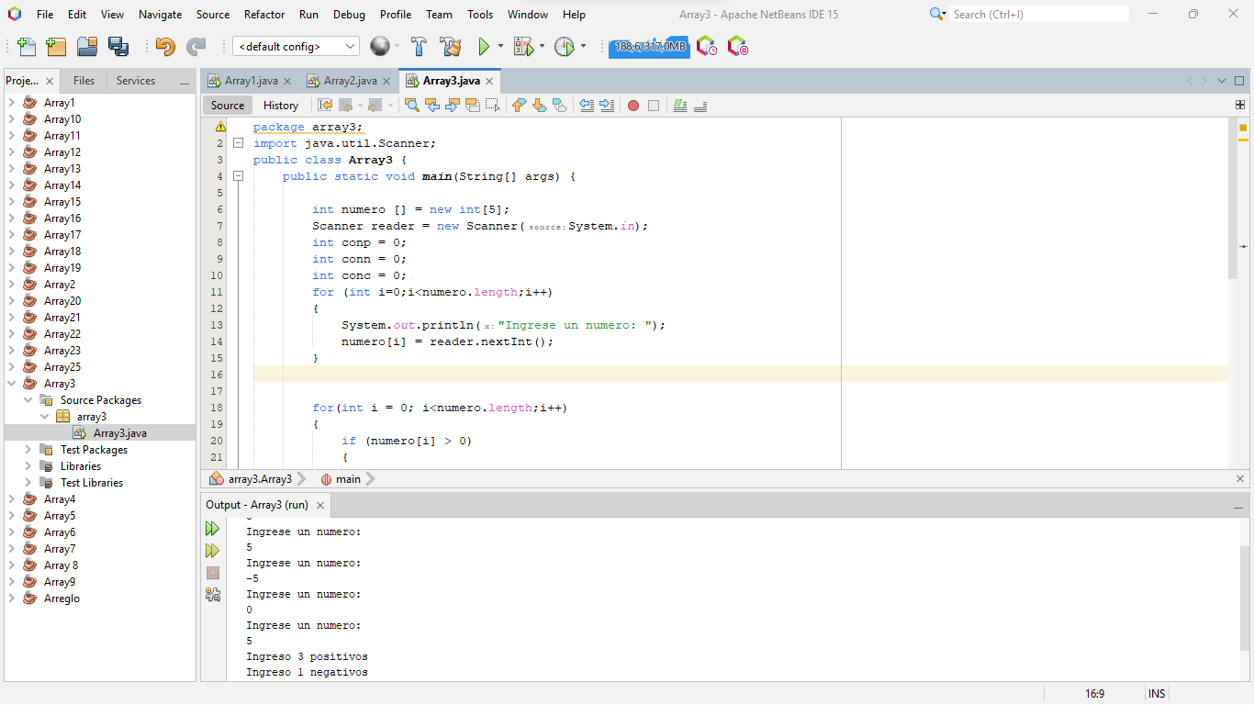

**Array 4**

package array4;

import java.util.Scanner;

public class Array4 {

public static void main(String[] args) {

int tabla [] = new int[5];

Scanner reader = new Scanner(System.in);

int numero;

int cont=0;

for (int i = 0; i<tabla.length;i++)

{

System.out.println ("Ingresa un valor: ");

tabla [i] = reader.nextInt();

}

for (int i = 0; i<tabla.length;i++)

{

if (tabla [i] > 0)

{

if (tabla [i] % 2 == 0)

{

cont++;

}

}

}

System.out.println ("Totla de numero postivos y pares son: "+cont);

}

}

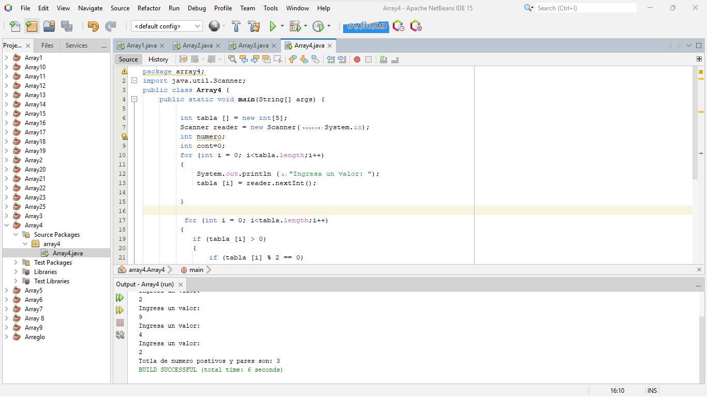

* **Array 5**

package array5;

import java.util.Scanner;

public class Array5 {

public static void main(String[] args) {

int vector [] = new int[5];

Scanner reader = new Scanner(System.in);

int num;

int num1;

int i ;

int sum = 0;

for( i = 0; i < vector.length;i++)

{

System.out.println("Ingrese un numero: ");

vector[i] = reader.nextInt();

}

System.out.println("Cuantos valores quiere sumar: ");

num = reader.nextInt();

for( i = 0; i < num; i++)

{

num1 = vector[i];

sum+=num1;

}

System.out.println("Respuesta "+sum);

}

}

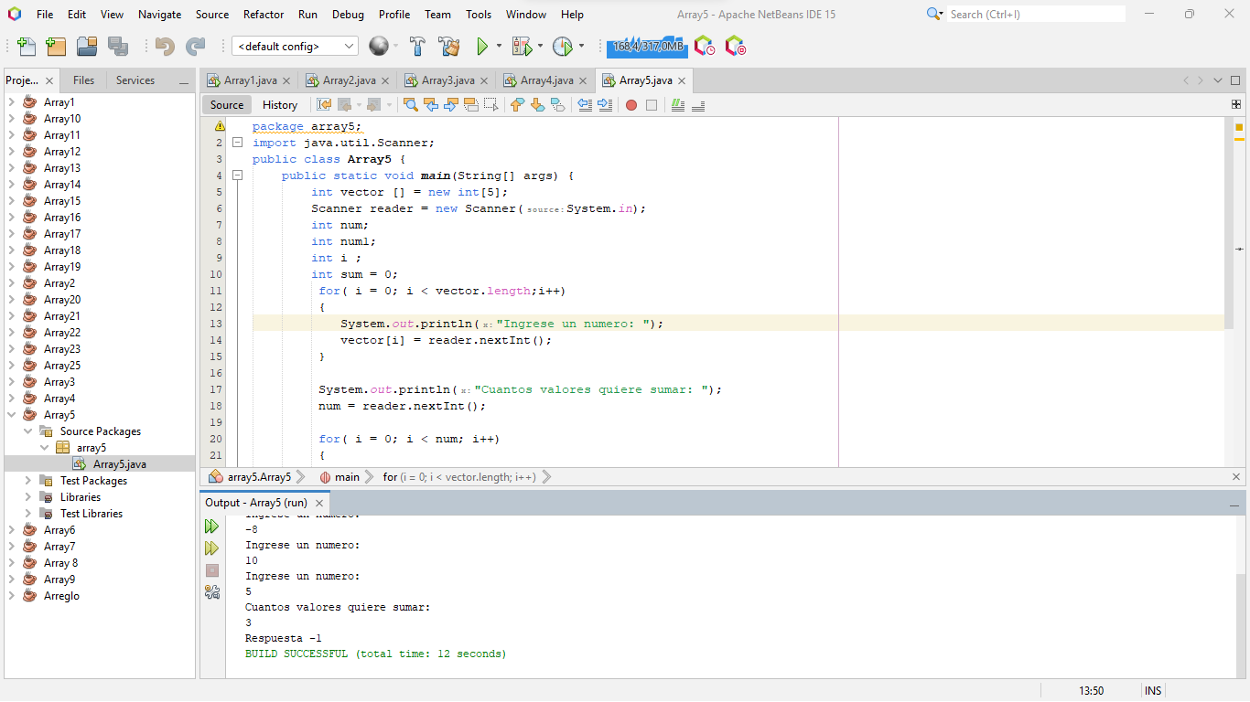

* **Array 6**

package array6;

import java.util.Scanner;

public class Array6 {

public static void main(String[] args) {

int array [] = new int[5];

Scanner reader = new Scanner(System.in);

int i;

int pos = -1;

for (i=0; i<array.length;i++)

{

System.out.println("Ingrese caulquier tipo de valores");

array[i]= reader.nextInt();

}

for (i=0; i<array.length;i++)

{

if ( array[i] > 30)

{

pos = i;

System.out.println("El valor "+array[i]+ " esta guardado en el espacio numero: "+pos);

}

else

{

System.out.println("LOS ELEMENTOS GUARDADOS EN LA ARRAY SON MENORES DE 30 SON" );

}

}

}

}

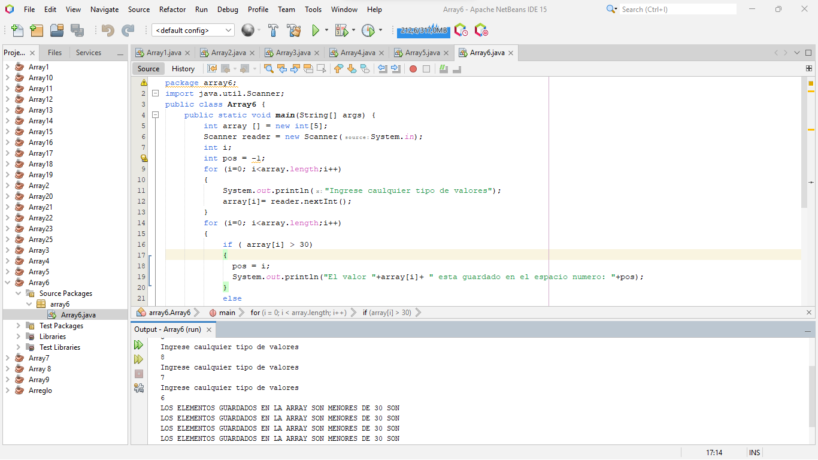

* **Array 7**

package array7;

import java.util.Scanner;

public class Array7 {

public static void main(String[] args) {

int origen [] = {10,25,26,40,37,45,90,76,78,81,58,32};

int destino[] = new int [origen.length];

int i;

System.out.print("Valores de la array original \n");

for (i = 0; i < destino.length ; i++)

{

destino[i] = origen [i];

System.out.print( +destino[i]+"-");

}

System.out.println("\nLos valores superiores a 25 son:" );

for (i = 0; i < destino.length ; i++)

{

if (destino[i]>25)

{

System.out.print(+destino[i]+"-");

}

}

}

}

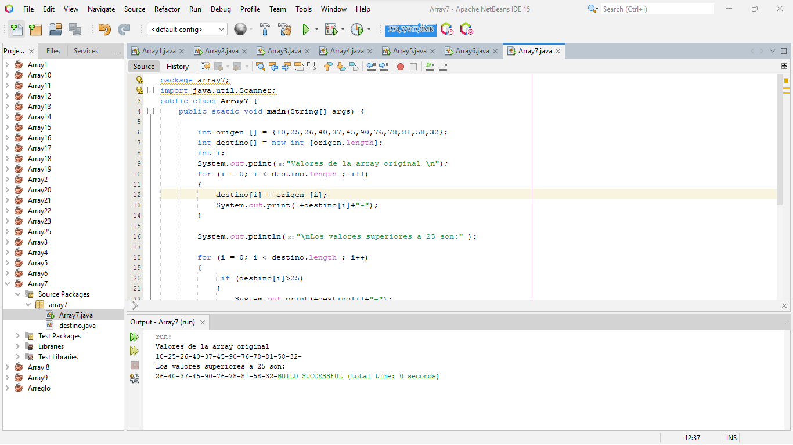

* **Array 8**

package array.pkg8;

import java.util.Scanner;

public class Array8 {

public static void main(String[] args) {

float notas [] = new float [10] ;

Scanner reader = new Scanner(System.in);

int i;

float cont=0;

float prom=0;

for (i=0;i<notas.length;i++)

{

System.out.println("Ingresa la nota de una asignatura: ");

notas[i] = reader.nextFloat();

}

for (i=0;i<notas.length;i++)

{

if (notas [i]<=10 && notas [i]> 0)

{

cont=cont+notas [i];

prom = cont/10;

}

else

{

System.out.println("La nota "+notas[i]+" es invalida");

}

}

System.out.println("La nota media es");

System.out.println(+prom);

}

}

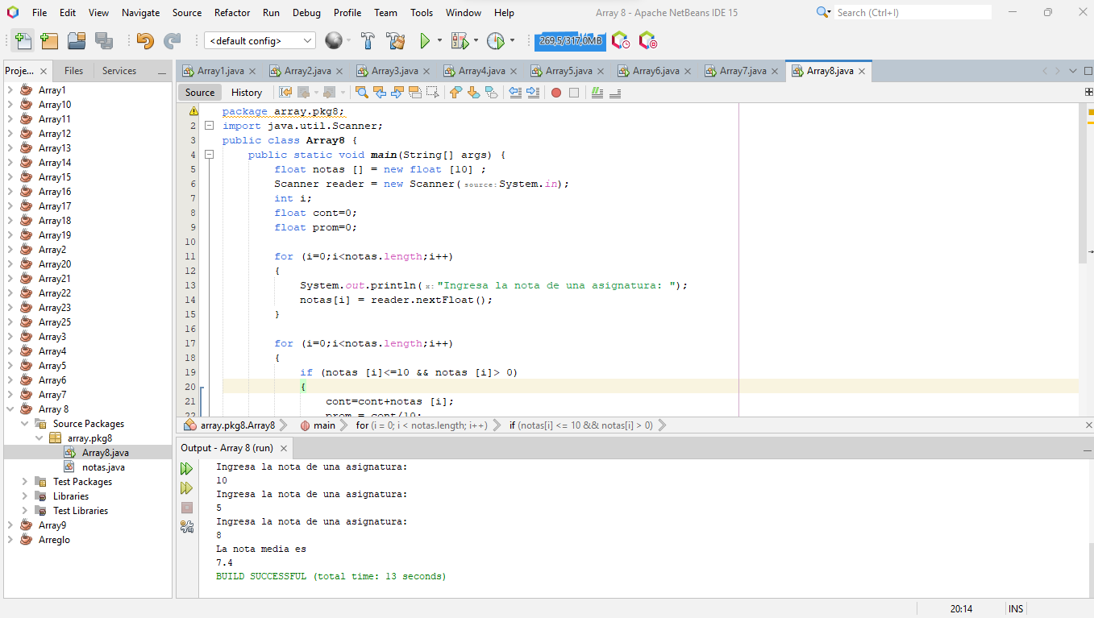

* **Array 9**

package array9;

public class Array9 {

public static void main(String[] args) {

int numeros [] = new int [15];

int i;

int n1=1;

System.out.println("Secuencia primaria");

for(i=0; i<numeros.length;i++)

{

numeros [i]= n1;

n1=n1+1;

System.out.print(+numeros [i]+"-");

}

System.out.println("\nSecuencia invetida");

for ( i = numeros.length - 1; i >=0 ; i--)

{

System.out.print(+numeros[i]+"-");

}

}

}

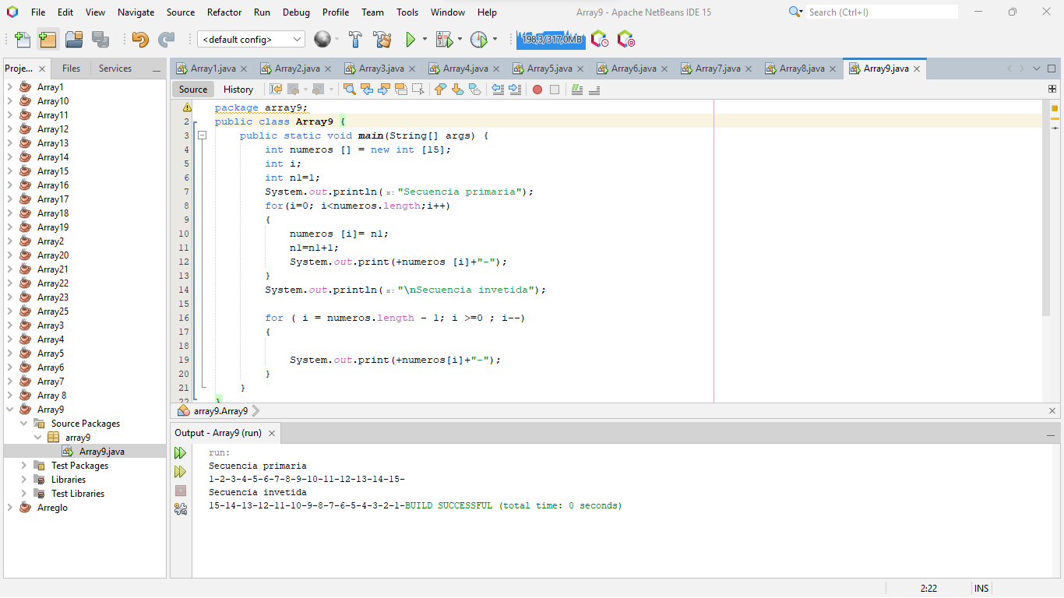

* **Array 10**

package array10;

import java.util.Scanner;

public class Array10 {

public static void main(String[] args) {

int respuesta [] = new int [10];

int positivos [] = new int [respuesta.length];

int negativos [] = new int [respuesta.length];

Scanner reader = new Scanner(System.in);

int i;

for (i=0;i<respuesta.length;i++)

{

System.out.println("Ingresa un valor");

respuesta[i] = reader.nextInt();

positivos [i] = respuesta [i];

negativos [i] = respuesta [i];

}

System.out.println("Los valores positivos son positivos");

for (i=0;i<positivos.length;i++)

{

if ( positivos[i] > 1)

{

System.out.println(+positivos[i]);

}

}

System.out.println("Los valores negativos son ");

for (i=0;i<negativos.length;i++)

{

if ( negativos[i]< 0)

{

System.out.println(+negativos [i]);

}

}

}

}

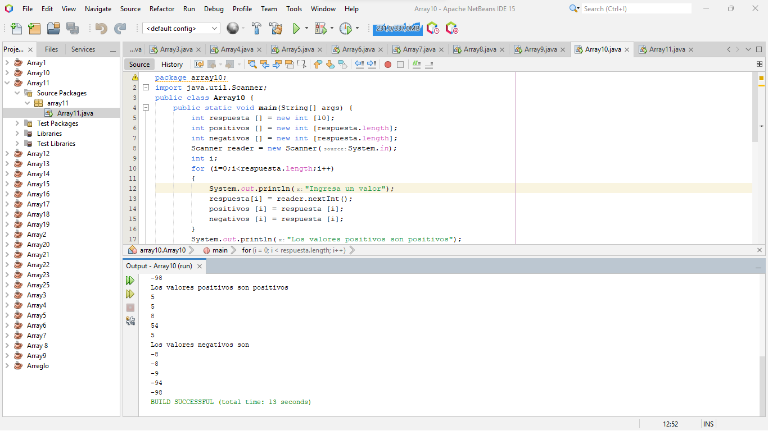

* **Array 11**

package array11;

import java.util.Scanner;

public class Array11 {

public static void main(String[] args) {

float numeros [] = new float [5];

Scanner leer = new Scanner(System.in);

int i;

float pos = numeros [0];

float numeromayor = numeros [0] ;

for( i=0;i<numeros.length;i++)

{

System.out.print("Ingresa un valor: ");

numeros[i] = leer.nextFloat();

}

for( i=0;i<numeros.length;i++)

{

pos=i;

System.out.println("El valor de la componenete "+pos+": "+numeros[i]);

}

for( i=0;i<numeros.length;i++)

{

if(numeros[i] > numeromayor)

{

pos = i;

numeromayor = numeros[i];

}

}

System.out.println("El numero mas grande es: "+numeromayor+ " y esta en la posicio "+pos);

}

}

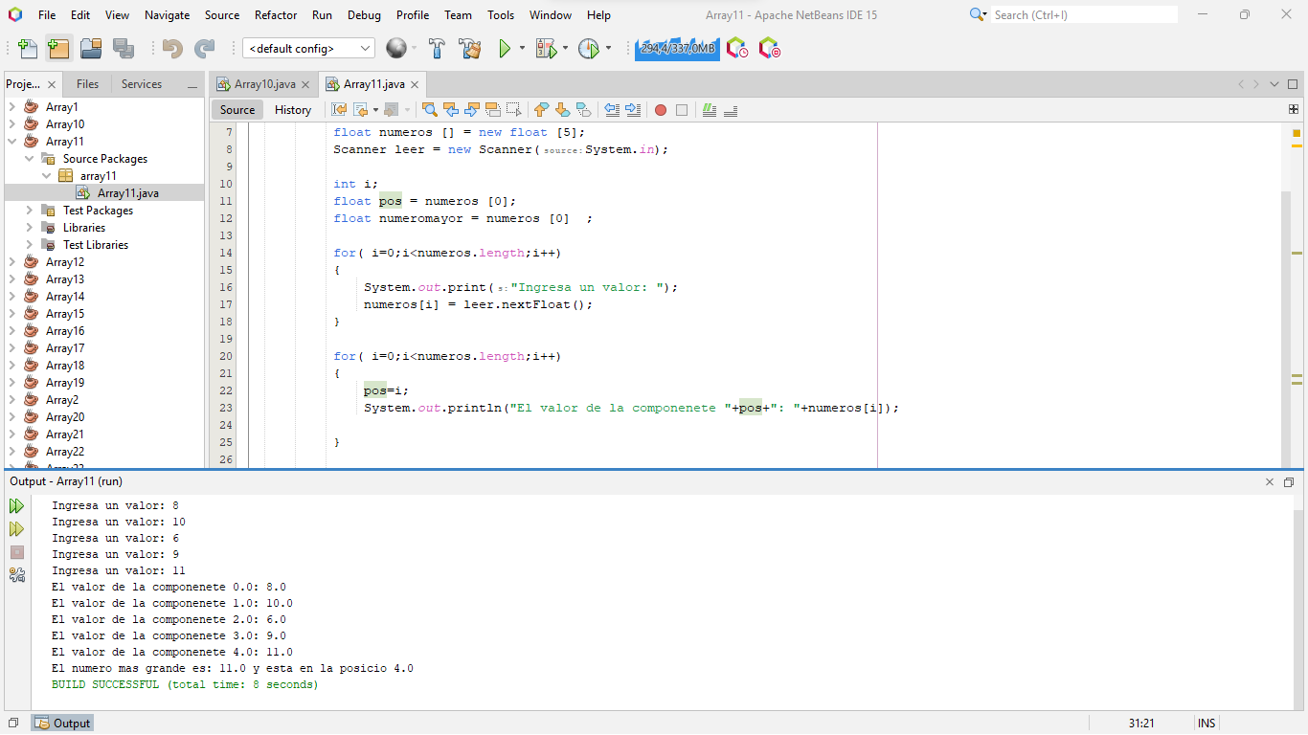

* **Array 12**

package array12;

public class Array12 {

public static void main(String[] args) {

int[][] matriz = new int[10][10];

for (int i = 0; i < matriz.length; i++) {

for (int j = 0; j < matriz[i].length; j++) {

if (i % 2 == 1)

{

matriz[i][j] = 1;

}

}

}

System.out.println("Matriz bidimensional:");

for (int i = 0; i < matriz.length; i++) {

for (int j = 0; j < matriz[i].length; j++) {

System.out.print(matriz[i][j] + " ");

}

System.out.println();

}

}

}

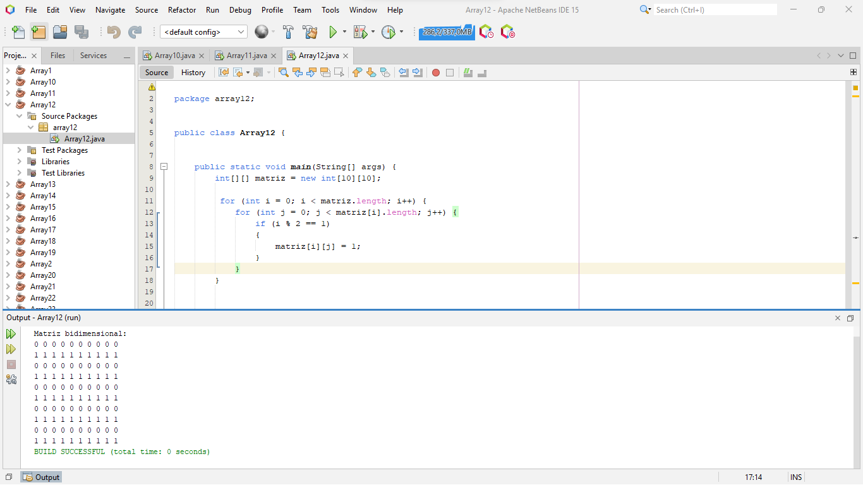

* **Array 13**

package array13;

public class Array13 {

public static void main(String[] args) {

int[][] datos = new int [10][10];

for (int i = 0; i< datos.length;i++)

{

for(int j = 0; j < datos[i].length; j++)

{

datos[i][j] = i+0;

}

}

for (int i = 0; i< datos.length;i++)

{

for(int j = 0; j < datos[i].length; j++)

{

System.out.print( datos[i][j]+" ");

}

System.out.println ();

}

}

}

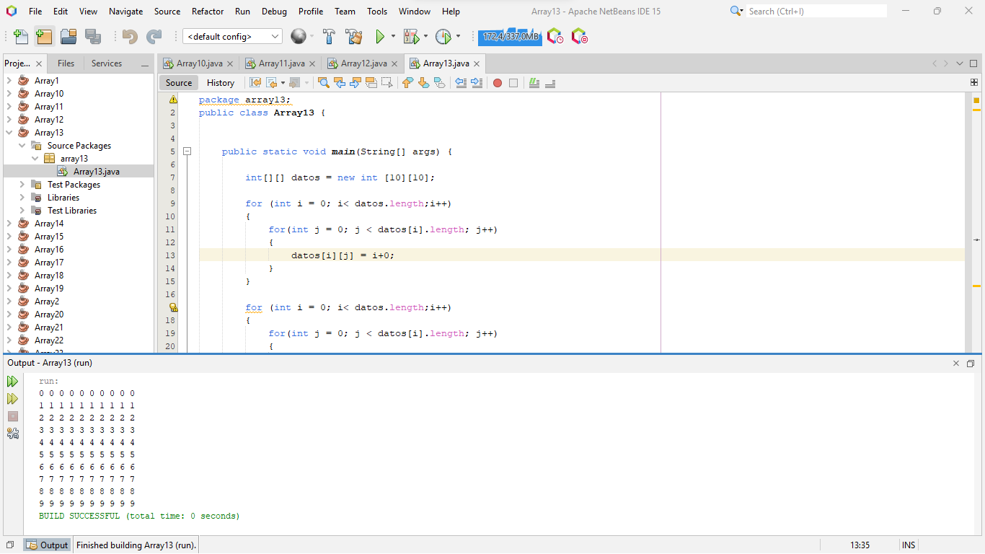

* **Array 14**

package array14;

public class Array14 {

public static void main(String[] args) {

int[][] datos = new int [10][10];

for (int i = 0; i < datos.length;i++)

{

for(int j = 0; j < datos[i].length; j++)

{

if (i + j == datos.length - 1)

{

datos[i][j] = 1;

}

}

}

for (int i = 0; i < datos.length;i++)

{

for(int j = 0; j < datos[i].length; j++)

{

System.out.print( datos[i][j]+" ");

}

System.out.println ();

}

}

}

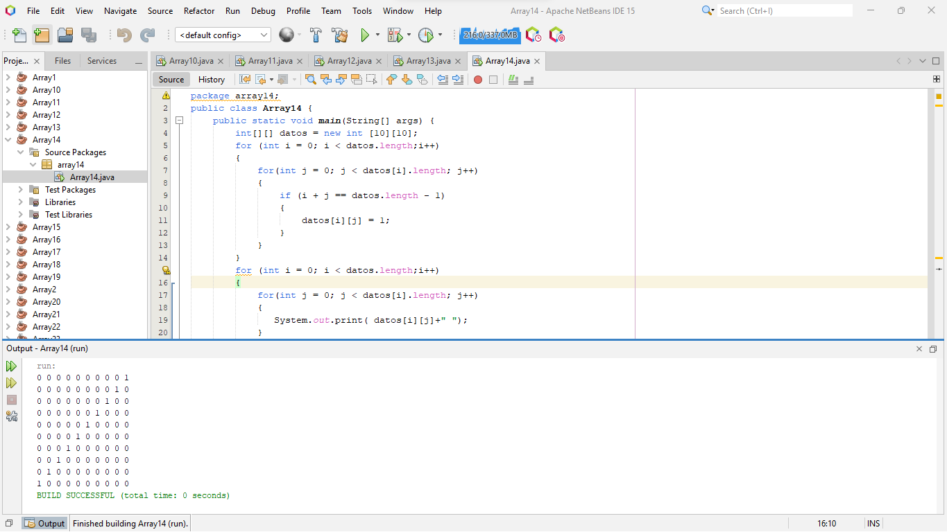

* **Array 15**

package array15;

import java.util.Scanner;

public class Array15 {

public static void main(String[] args) {

int[][] datos = new int [10][10];

Scanner reader = new Scanner(System.in);

int sumafi = 0;

int sumaco = 0;

for (int i = 0; i < datos.length;i++)

{

for(int j = 0; j < datos[i].length; j++)

{

datos [i][j] = j;

}

}

System.out.println ("\nEstos valores son los que escribio en la array\n");

for (int i = 0; i < datos.length;i++)

{

for(int j = 0; j < datos[i].length; j++)

{

System.out.print( "{"+datos[i][j]+"}");

}

System.out.println ();

}

//suma de fila //

System.out.println("\nLos resultados de las sumas de las filas es\n");

for (int i = 0; i < datos.length;i++)

{

for(int j = 0; j < datos[i].length; j++)

{

sumafi = sumafi + datos [i][j];

}

System.out.print("La suma de la fila es: "+sumafi);

sumafi = 0;

System.out.println ();

}

// suma de columnas

System.out.println("\nLos resultados de las sumas de las columnas es\n");

for (int i = 0; i < datos.length;i++)

{

for(int j = 0; j < datos[i].length; j++)

{

sumaco = sumaco + datos [j][i];

}

System.out.print("La suma de las columnas es: "+sumaco);

sumaco = 0;

System.out.println ();

}

}

}

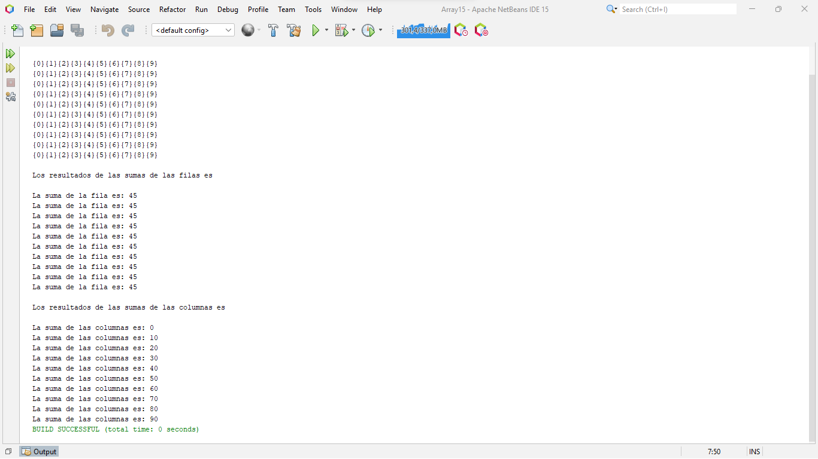

Ejercicios extras

* **Array 16**

package array16;

import java.util.Scanner;

public class Array16 {

public static void main(String[] args) {

int[][] numeros = new int [3][3];

Scanner reader = new Scanner(System.in);

System.out.println ("Ingresa los valores dentro de la array");

for (int i = 0; i < numeros.length;i++)

{

for(int j = 0; j < numeros[i].length; j++)

{

numeros [i][j] = reader.nextInt();

}

}

System.out.println ("\nLos valores ingresados son pares\n");

for (int i = 0; i < numeros.length;i++)

{

for(int j = 0; j < numeros[i].length; j++)

{

if ( numeros [i][j] %2 == 0)

{

System.out.print (+numeros [i][j]+" ");

}

}

}

System.out.println ("\n\nLos valores ingresados son impares\n");

for (int i = 0; i < numeros.length;i++)

{

for(int j = 0; j < numeros[i].length; j++)

{

if ( numeros [i][j] % 2 == 1)

{

System.out.print (+numeros [i][j]+" ");

}

}

}

}

}

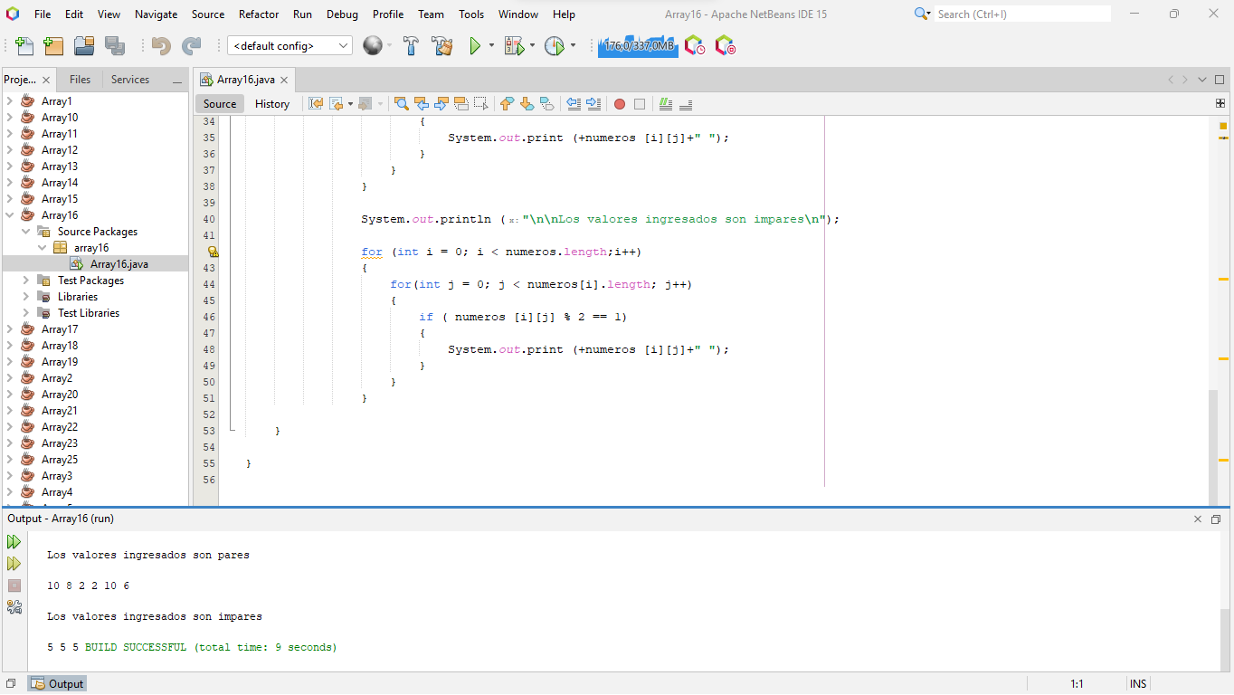

* **Array 17**

package array17;

import java.util.Scanner;

public class Array17 {

public static void main(String[] args) {

int [] numero = new int [2];

Scanner reader = new Scanner(System.in);

int pos;

int mult = 0;

for (int i = 0 ;i<numero.length;i++)

{

pos=i;

System.out.println("Ingresa un numero "+pos);

numero[i] = reader.nextInt();

mult = numero[0]* numero[1];

}

System.out.println("El producto de los 2 numeros es: "+mult);

}

}

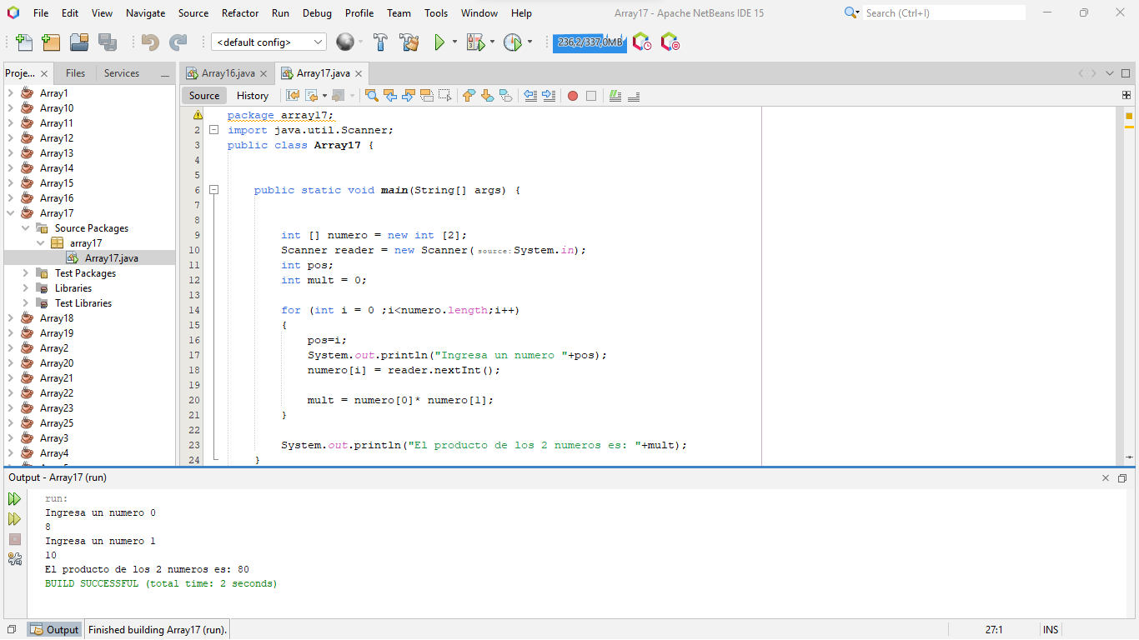

* **Array 18**

package array18;

import java.util.Scanner;

public class Array18 {

public static void main(String[] args) {

int num [] = new int [2];

Scanner reader = new Scanner(System.in);

int mayor = 0;

for (int i = 0; i<num.length;i++)

{

int pos = i;

System.out.println("Ingresa un valor "+pos);

num [i] = reader.nextInt();

}

for (int i = 0; i<num.length;i++)

{

if (num [i] > mayor)

{

mayor = num [i];

}

}

System.out.println("El numero mayor es: "+mayor);

}

}

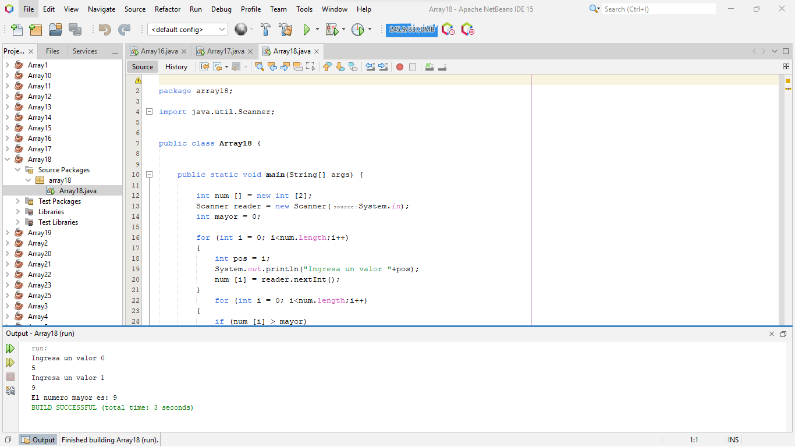

* **Array 19**

package array19;

import java.util.Scanner;

public class Array19 {

public static void main(String[] args) {

int num [] = new int [3];

Scanner reader = new Scanner(System.in);

int mayor = 0;

for (int i = 0; i<num.length;i++)

{

int pos = i;

System.out.println("Ingresa un valor "+pos);

num [i] = reader.nextInt();

}

for (int i = 0; i<num.length;i++)

{

if (num [i] > mayor)

{

mayor = num [i];

}

}

System.out.println("El numero mayor es: "+mayor);

}

}

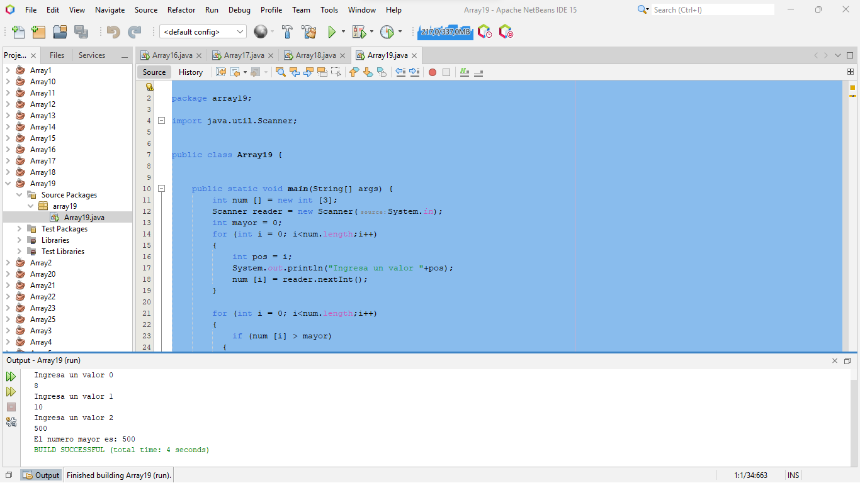

* **Array 20**

package array20;

import java.util.Scanner;

public class Array20 {

public static void main(String[] args) {

int [] num = new int [1];

Scanner reader = new Scanner(System.in);

int mult =0;

System.out.println("INGRESE EL NUMERO QUE DESEA SABER SU TABLA DE MULTIPLICAR");

for (int i=0; i < num.length ; i++)

{

num [i]= reader.nextInt();

System.out.println("La tabla de multiplicar del "+num [i]+" es:");

for (int j = 1; j < 11; j++)

{

mult = num [i] * j;

System.out.println(+num [i]+"*" +j+ "=" +mult);

}

}

}

}

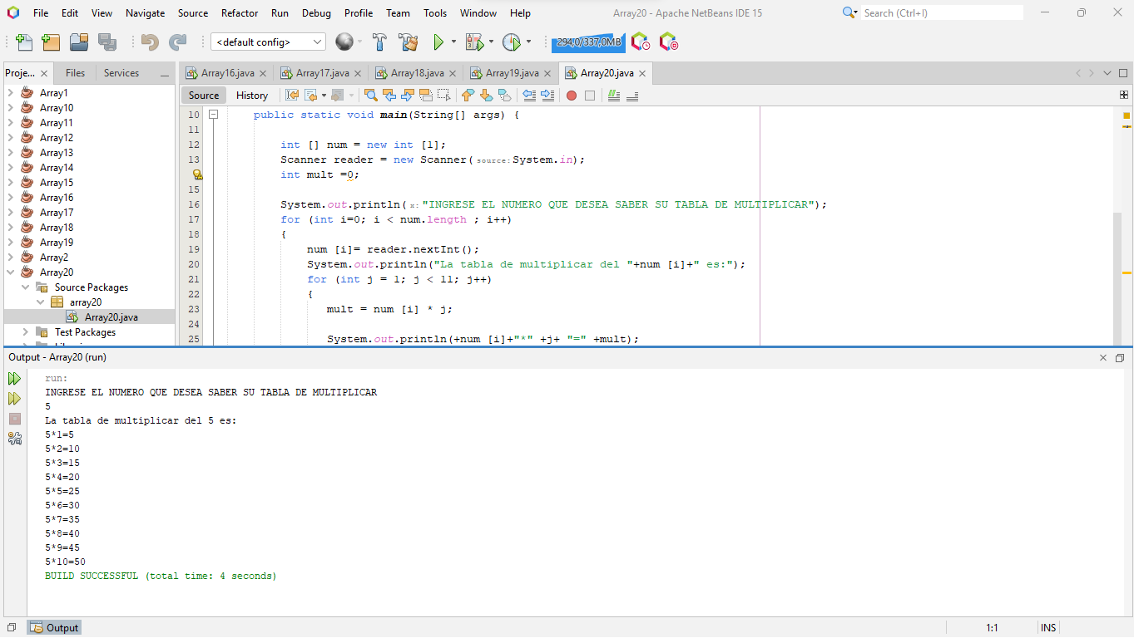

* **Array 21**

package array21;

import java.util.Scanner;

public class Array21 {

public static void main(String[] args) {

int [] num = new int [30];

int suma = 0;

for (int i =0; i<num.length;i++)

{

num[i] = i;

suma = suma + i;

System.out.println(""+ num[i]);

}

System.out.println("La suma de todos los numeros es: "+ suma);

}

}

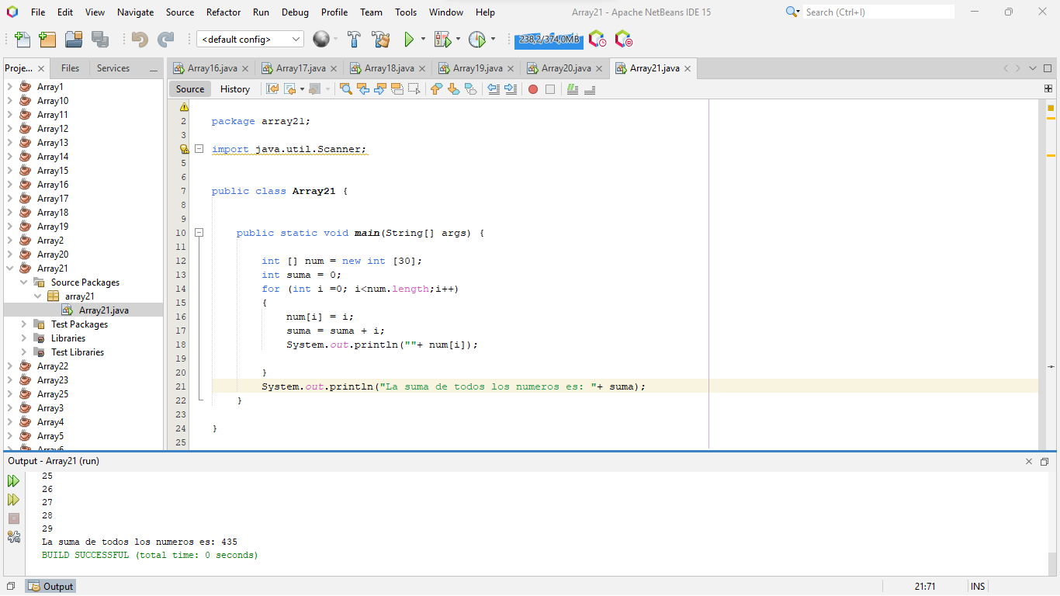

* **Array 22**

package array22;

import java.util.Scanner;

public class Array22 {

public static void main(String[] args) {

int[] secuen = new int [10];

Scanner reader = new Scanner(System.in);

int i = 0;

int suma = 0;

do

{

System.out.print("Ingresa un valor: ");

secuen[i] = reader.nextInt();

if (secuen[i] > 0)

{

suma = suma + secuen[i];

}

}while (secuen[i] > 0);

System.out.print("La suma de los valores ingresados es: "+suma);

}

}

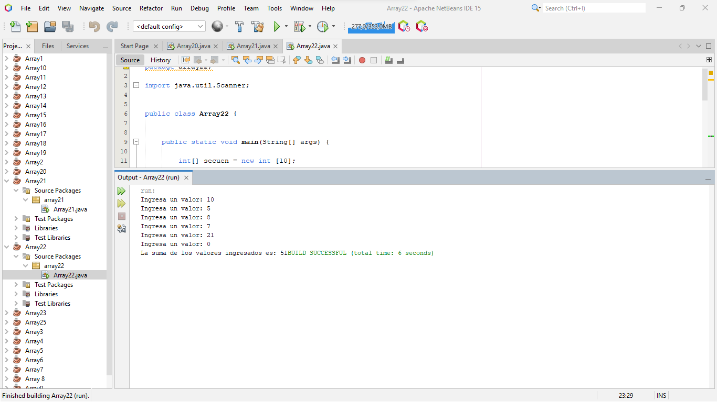

* **Array 23**

package array23;

import java.util.Scanner;

public class Array23 {

public static void main(String[] args) {

int [] num = new int [2];

Scanner reader = new Scanner(System.in);

int valor = 0;

int suma = 0;

for (int i = 0; i <num.length ;i++)

{

System.out.println("Ingrese su primer valor");

num[i] = reader.nextInt();

valor = num[0];

}

for (int i = 0; i < num [1];i++)

{

suma = suma + valor;

}

System.out.println("El resultado de tu producto mediante suma es: "+suma);

}

}

